# Heap Organized Tables

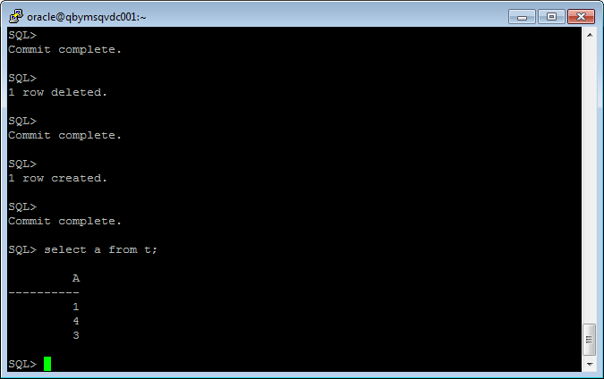

Block size is 32kB, percent of free space – 10 % and 1 row has size ~8 kB.

So block will be filled with 3 rows almost totally. After the second row is deleted, the next row will be inserted on the free space in block, on the place of the deleted row.

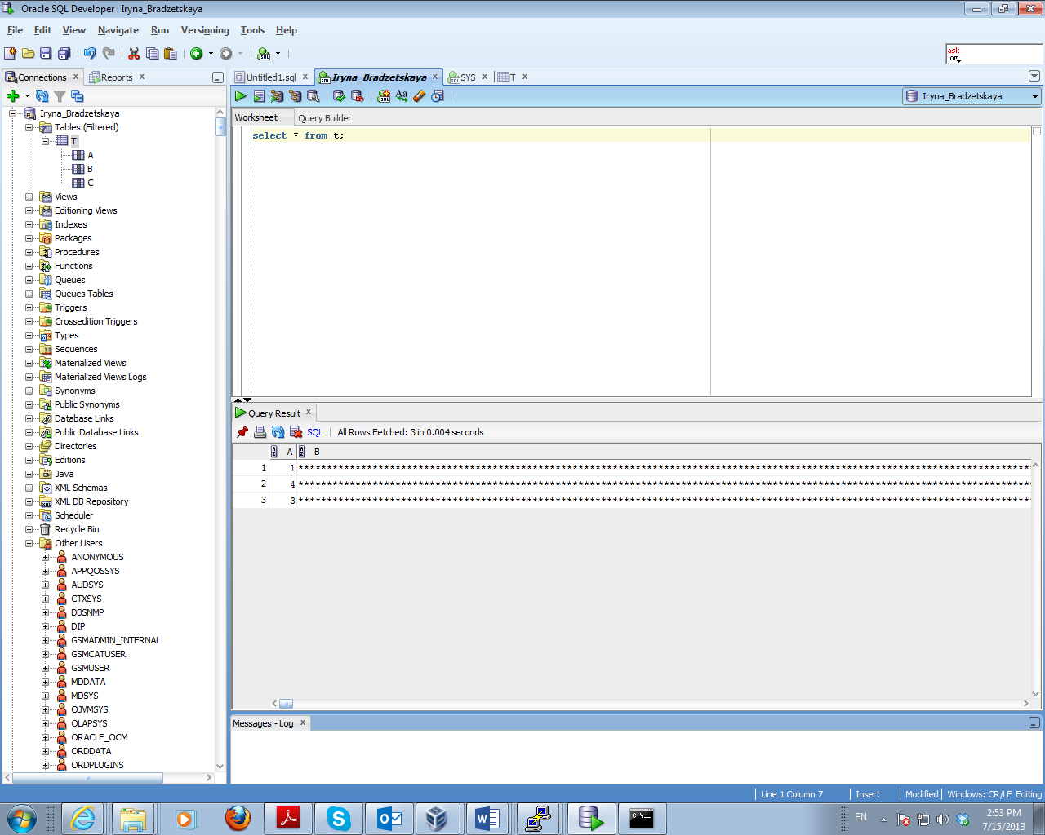

# Index Organized Tables

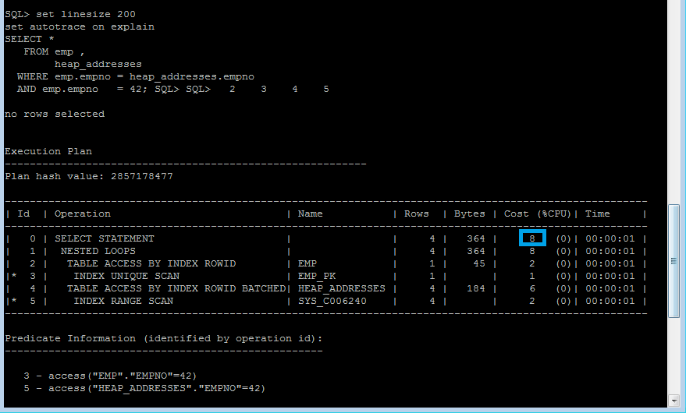

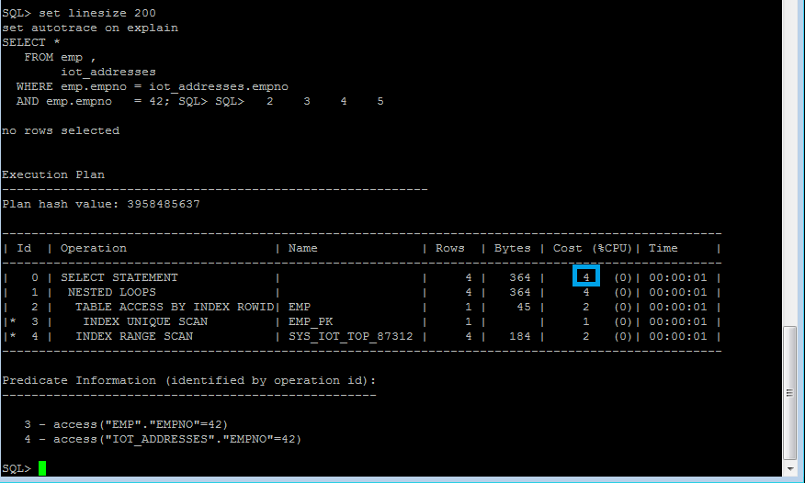 The comparison of the results shows that the selection from IOT have lower cost than the selection from heap-table because all data is contained in IOT and there is no need to find any data in another table as it happened in the execution plan with heap-table.

# Index Clustered Tables

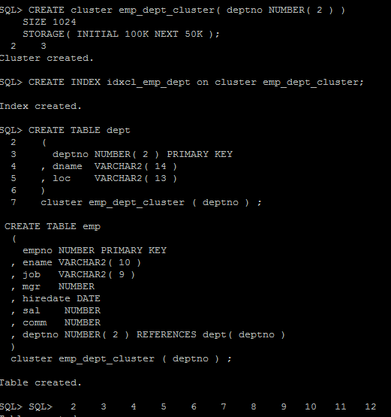

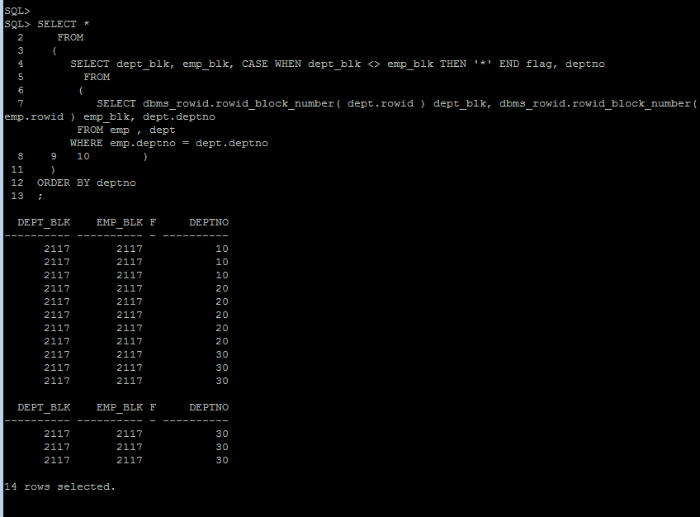

# A clustered index forces the rows to be stored in sorted order according to the index key. With a cluster, a single block of data may contain data from many tables.

# Advantages of this type of storage are that you can read via indexes, either the cluster key index or other indexes you put on the tables in the cluster, and join this information together frequently, because of all of the information about the set of columns of a table or index are stored physically on the same block

# Hash Clustered Tables

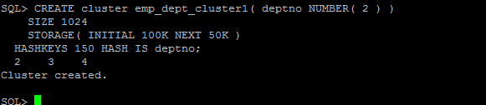

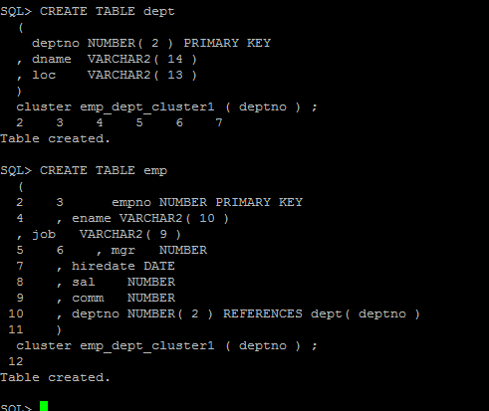

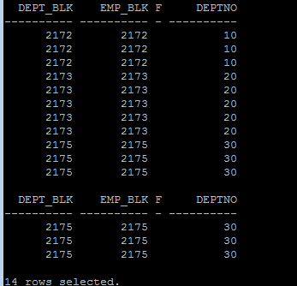

The differences between Index Clustered tables are that the cluster key index is replaced with a hash function. Oracle will take the key value for a row, hash it using either a function and use that to figure out where the data should be on disk.